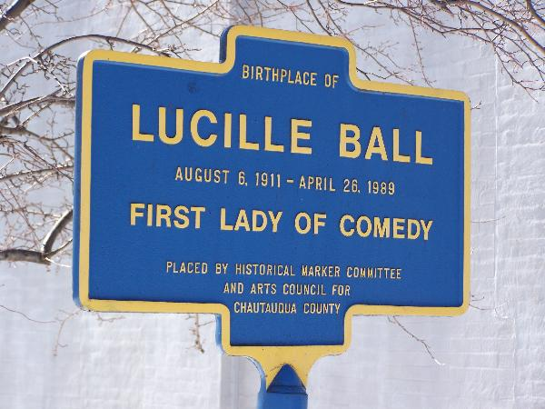
Attention all Lucille Ball fans! Are you looking for a fun and interesting way to spend your free time? Maybe an entertaining weekend getaway to explore the life of the Queen of Comedy? If so, Jamestown, New York is the place to visit! Offering countless Lucille Ball attractions and events, including the annual Lucille Ball Comedy Fest, Desilu Studios, her childhood home, and her grave where she is buried, exhibits filled with the classic costumes and on-set scenes, and so much more, Jamestown is a must-see city! Let the memory and the love of Lucy live on!
Live comedy, bands, and food! (1)
Lucille Ball Puts Jamestown
‘on the map’…
The Birthplace of Lucille Ball
Location: 69 Stewart Avenue, Jamestown, New York (1)
Come view the original house where Lucille Ball was born! This is a private residence, but you are more than welcome and encouraged to observe it from the street! 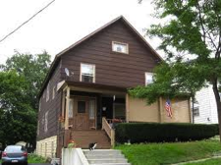
The Childhood Home of Lucille Ball
Location: 59 Lucy Lane (Formerly 8th St.), Celoron (1)
Lucille Ball spent much of her adolescence growing up in this home. Its current owners are spending quite a bit of time restoring it to its 1920s style, and it will be open for tours as soon as the restorations are complete.
(1)
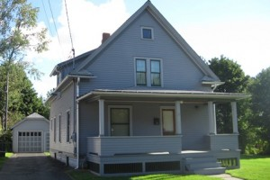
Picnic with friends and family at Lucille Ball Memorial Park! (1)
Tour of Lucy’s hometown! (1)
Recreated scenes from I Love Lucy episodes! (1)
Participate in a silent auction on your favorite Lucy apparel! (1)
Attractions?
Lucille Ball
Comedy Festival
Lucille Ball was born in Jamestown, NY on August 6, 1911 and spent much time growing up in this city.

Over 20,000 tourists visit the Lucy Desi Museum in Jamestown each year (2).

Just last year, Jamestown “attracted 13,000 fans from around the world, a $3.6 million impact on the Chautauqua County economy”(2).

A two-hour cruise around Chautauqua Lake because we all know Lucy loved the water! (1)
FACTSS
FUN

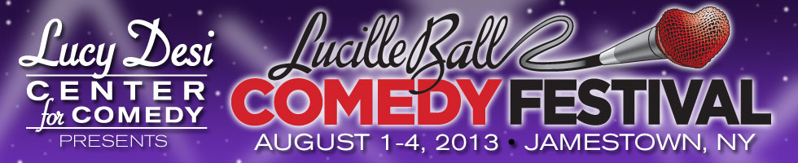
Lucy’s Burial Place
Location: Lake View Cemetery
907 Lakeview Avenue, Jamestown, 665-3206 (1)
Come pay your respects and visit the tombstone of this famous star!
August 1-4, 2013
Jamestown, NY

